**Survey Results**

# **Q.1 Do you prefer websites to have a predominantly dark or light colour scheme?**

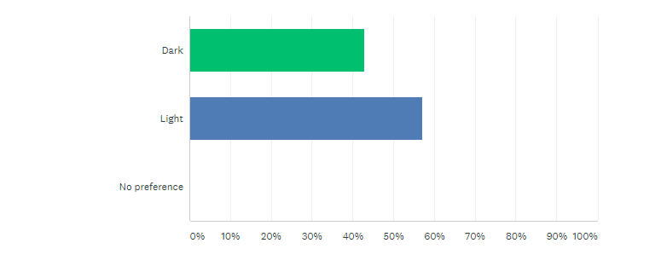

Note: As a result of the survey, we opted to use a grey colour colour scheme. Our answers were roughly equal, so we decided to go for an option that was a predominantly dark colour but with light shades.

# **Q.2 Do you prefer to read text on a dark background or a light background?**

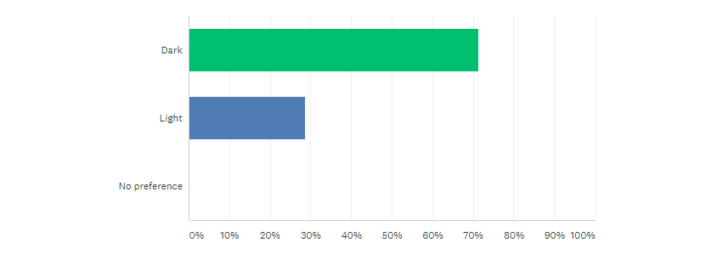

Note: As a result of the survey, we opted to use a grey background, that was quite dark in shade.

# 

# **Q.3 Do you like sites you visit to have bright colours incorporated into their design?**

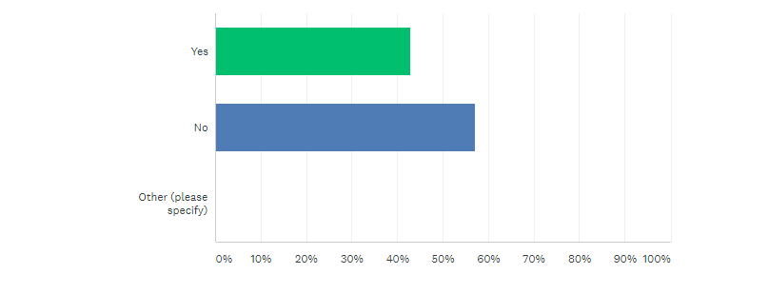

Note: As a result of our survey, we opted to use a primarily grey, muted colour scheme.

# 

# **Q.4 Do you like sites you visit to have lots of pictures or very few?**

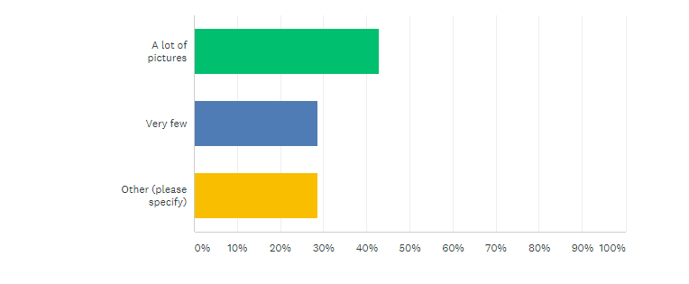

Selected responses:

“Don’t mind”

“A good balance, as long as they are relevant.”

Note: As a result of the survey, we took one of our responses into account. Our final website does not have many pictures, but we did not feel we had any relevant pictures, so for this reason, we left them out.

# **Q.5 Do you like sites you visit to have an overview of information or do you prefer to search for this yourself?**

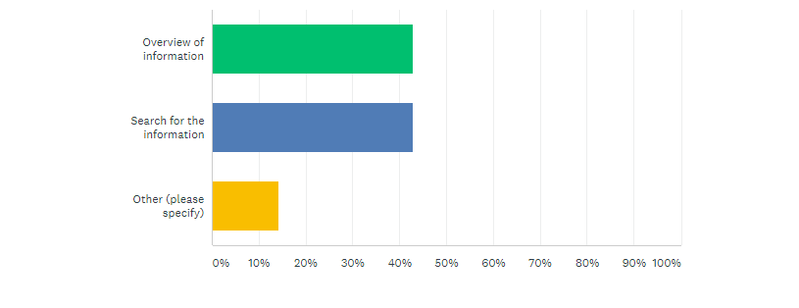

Selected responses:

“Depends on the website”

“A mix of the two, I like an overview of categories, then being able to search the filtered results.”

Note: As a result of the survey, we opted to utilise both options in different parts of the website.